TOOL 22: WESTERN CAPE STANDARDISED INCIDENT COMMAND FORM

1. Incident Name | 2. Operational Period | IAP COVER SHEET
1. Incident Name | Date  Time | IAP COVER SHEET
INCIDENT ACTION PLAN

The items checked below are included in the Incident Action Plan
□ SITUATION REPORT
□ INCIDENT OBJECTIVES
□ ORGANISATIONAL LIST
□ SECTOR ASSIGNMENT
□ DIVISIONAL ASSIGNMENT
□ AIR OPERATIONS PLAN
□ COMMUNICATION PLAN
□ SAFETY PLAN
□ MEDICAL PLAN
□ FIRE MAP
□ WEATHER FORECAST AND MAP
□ FIRE BEHAVIOUR FORECAST
□ FACILITIES
3. Approved by Incident Commander:  Name | Signed | Date/Time

1. Incident Name | 2. Operational Period | SITUATION  REPORT
1. Incident Name | Date:  Time: | SITUATION  REPORT
3. Location | 4. Vegetation  Plantation/Mountain fynbos/ Coastal fynbos/ Grass/Slash/  Alien veld  Other: | 5. 1:50000 Map ref. GIS ref.
6. Assessment

7. Action taken

8. Factors

9. Predicted Incident Development

10. Prepared by: |  | Date/Time:

1. Incident Name | 2. Operational Period | INCIDENT  OBJECTIVES
1. Incident Name | Date:  Time: | INCIDENT  OBJECTIVES
3. Overall Incident Objectives

4. Objectives for specified Operational Period

5. Prepared by: |  | Date/Time:

1. Incident Name | 2. Operational Period  Date:  Time: |  |  |  | ORGANISATION LIST
3. Command Staff |  |  | Phone |  | Cell Phone |  | Radio Channel
Incident Commander
Deputy Incident Commander
Information Officer
Safety Officer
Liaison Officer
4. Agency Representative |  |  | Phone |  | Cell Phone |  | Radio Channel
Lead Agency
Agency
Agency
Agency
5. Planning Section |  |  | Phone |  | Cell Phone |  | Radio Channel
Planning Section Chief
Situations Unit
Resources Unit
Management Support Unit
Information Unit
Advance Planning Unit
Technical Specialists Unit
6. Logistics Section |  |  | Phone |  | Cell Phone |  | Radio Channel
Logistics Section Chief
Supply Unit
Catering Unit
Facilities Unit
Finance Unit
Communications Unit
Medical Unit
7. Operations Section |  |  |  | Phone |  | Cell Phone |  | Radio Channel
Operations Section Chief
Deputy Operations Manager
Division One Commander
Sector A Supervisor
Sector B Supervisor
Sector C Supervisor
Sector D Supervisor
Division Two Commander
Sector E Supervisor
Sector F Supervisor
Sector G Supervisor
Sector H Supervisor
Air Division Commander
Air Attack Supervisor
Air Support Supervisor
8. Prepared by: |  |  |  | Date/Time

1. Incident Name | 2. Operational Period |  |  |  | SECTOR  ASSIGNMENT
Date:
Time:
3. Sector | 4. Description |  |  |  | 5. Division Assigned
6. Sector Supervisor |  |  | Affiliation |  | Phone | Radio Channel
7. Resources assigned this period
Resource/Crew | Leader | # Persons |  | Transport Required | Drop-off Point / Time | Pickup Point / Time
8. Sector Assignment / Special Instructions

9. Sector Communications |  |  |  |  | Phone | Radio Channel
Division / Division Commander
Aerial Attack Supervisor
Safety Officer
10. Prepared By: |  |  |  |  | Date / Time

1. Incident Name |  | 2. Operational Period |  | DIVISION  ASSIGNMENT
Date:
Time:
3. Sector |  | 4. Description
5. Division Commander |  |  | Affiliation | Phone | Radio Channel
6. Resources assigned this period
Sector | Supervisor |  | Crews |  | Radio Channel
7. Division Assignment / Special Instructions

8. Division Communications |  |  |  | Phone | Radio Channel
Operations Manager
Aerial Division Commander
9. Prepared By: |  |  |  | Date / Time

1. Incident Name | 2. Operational Period |  |  |  |  | AIR OPERATIONS PLAN
1. Incident Name | Date: Time:
3. Personnel and Communications
Position |  | Name |  | Affiliation |  | Phone |  | Radio Channel
Air Divisional Commander
Air Attack Supervisor
Air Support Supervisor
Lead Helicopter Pilot
Lead Fixed-Wing Pilot
4. Air Resource Assignments
Pilot Name / Company | Aircraft Type |  | Reg or  Call Sign |  | Assignment |  | Tactical  Freq/Ch |  | Telephone Numbers
Onboard:
Company
Onboard:
Company
Onboard:
Company
Onboard:
Company
Onboard:
Company
Onboard:
Company
Onboard:
Company
Onboard:
Company
5. Location of Filling Points / Service areas
Name |  |  | Grid Reference
6. Safety Notes / Hazards / Radio Coverage Limitations
7. Air Operations Special Equip or Service
8. Prepared By: |  |  |  |  |  | Date / Time

1. Incident Name | 2. Operational Period  Date:  Time: |  | COMMUNICATIONS  PLAN
3. Radio Channels
Assigned To | Function | Channel | Frequency | System
4. Telephone
Assigned To | Landline | Cell phone | Fax | Comments
5. Other (e.g. email, satphone, etc)
6. Prepared By: |  |  | Date / Time

1. Incident Name | 2. Operational Period | SAFETY PLAN
1. Incident Name | Date:  Time:
3. General Safety Points
Everyone is to be signed in and out of the fire ground through the Incident Control Point for both safety check and payment records.
Maintain regular situation reports (containing all relevant information) via line supervisors.
LACES | Fire Orders |  | Watch-outs
L – Lookout(s)  A – Awareness  – Anchor Point(s)  C – Communication(s)  E – Escape Route(s)  S – Safety Zone(s) | 1. Conditions and forecasts.  2. Know what your fire is doing at all times.  3. Base all actions on current and  expected behaviour of the fire.  4. Identify escape routes and safety zones and make them known.  5. Post lookouts when there is possible danger.  6. Stay alert. Keep calm. Think clearly. Act decisively.  7. Maintain prompt communication with your crews, your supervisor and adjoining crews.  8. Give clear instructions and ensure they are understood.  9. Maintain control of your crews at all times.  10. Fight fire aggressively, having  provided for safety first. |  | 1. Fire size is unknown (no size up).  2. Unfamiliar territory.  3. Safety zones and escape routes not identified.  4. Unfamiliar with weather and local factors influencing fire behaviour.  5. No communications link with crew members or supervisor.  6. Instructions and assignments not clear.  7. Weather is getting hotter, drier and relative humidity dropping.  8. Wind increases and/or changes direction.  9. Getting frequent spot fires across the line.  10. Working on a steep slope.  12. Working in rugged terrain.  13. Can’t see main fire.  14. In unburnt vegetation.  15. Walking through hot ashes.  16. Working alone.  17. Getting tired.  18. Working near machinery.  20. Working with aircraft.  21. Working around trees or spars.
4. Specific Safety Points

6. Prepared By: |  | Date / Time

1. Incident Name |  |  |  |  |  | 2. Operational Period |  |  |  |  |  |  |  |  |  |  |  |  |  | MEDICAL PLAN
 |  |  |  |  |  | Date: Time:

3. First Aid Station
Name |  |  |  |  |  | Location |  |  |  |  | Phone/Radio Channel |  |  |  |  |  |  |  |  | Paramedics available at  Station

4. Transportation
Ambulance Service |  |  |  |  |  | Address |  |  |  |  | Phone/Radio Channel |  |  |  |  |  |  |  |  | Paramedics available with ambulance

5. Hospitals
Hospital Name |  |  |  |  |  | Address |  |  |  |  | Phone |  |  |  |  | Travel Time
 |  |  |  |  |  |  |  |  |  |  |  |  |  |  |  | Road |  |  |  | Air |  |  |  |  | Burn Unit |  |  |  | Heli Pad

6. Special Emergency Procedures:
7. Prepared By: |  |  |  |  |  |  |  |  |  |  |  |  |  |  |  |  |  |  |  | Date / Time
8. Reviewed by Safety Advisor: |  |  |  |  |  |  |  |  |  |  |  |  |  |  |  |  |  |  |  | Date / Time

INCIDENT ORGANISER VELDFIRE
Situation Report
Incident Name: |  |  |  |  |  |  |  |  |  |  |  |  |  |  |  |  |  |  |  |  |  |  | Shift:
Location:
Incident Number: |  |  |  |  |  |  |  |  |  |  |  |  |  |  |  |  |  |  |  |  |  |  | Date:
Incident Type:
Grid Reference: |  |  |  |  |  |  |  |  |  |  |  |  |  |  |  |  |  |  |  |  |  |  | Hours:
Assessment: Current situation (Note any critical issues & assumptions made)
Action Taken: (Consider Progress)
Factors: (Weather and other factors or limitation should be noted, including resource status)
Predicted Incident Development: (Note how this situation is expected to evolve)
Resource Summary
Resources Ordered (hrs) |  |  | Resources Type & Name Call Sign |  |  |  |  |  | ETA (hrs) |  | Arrival (hrs) |  |  |  | Location / Assignment / Comment |  |  |  |  |  |  |  |  |  |  |  |  |  | Time Released (hrs)
Completed by: |  |  |  |  |  |  |  |  |  |  |  |  |  |  | Date:
Position: |  |  |  |  |  |  |  |  |  |  |  |  |  |  | Time:
Hints for successful Incident Management: |  |  |  |  |  |  |  |  |  |  |  |  |  |  | Situation Report:
Keep records  Plan ahead  Set up a Command and Control structure  Delegate functions  Develop and update Incident Action Plans  Brief personnel  Sectorise the incident  Give regular Situation Reports  Plan changeovers  Have effective communications |  |  |  |  |  |  |  |  |  |  |  |  |  |  | On Arrival |  |  |  |  |  |  | Prepared & Communicated: |  |  |  |  |  |  | Time:
 |  |  |  |  |  |  |  |  |  |  |  |  |  |  | + 1 hr
 |  |  |  |  |  |  |  |  |  |  |  |  |  |  | + 2 hrs
 |  |  |  |  |  |  |  |  |  |  |  |  |  |  | + 3 hrs
 |  |  |  |  |  |  |  |  |  |  |  |  |  |  | + 4 hrs
 |  |  |  |  |  |  |  |  |  |  |  |  |  |  | + 5 hrs
 |  |  |  |  |  |  |  |  |  |  |  |  |  |  | Safety First, Every Job, Every time (L.A.C.E.S.)

INCIDENT ORGANISER VELDFIRE
Incident Action Plan
Incident Objective / Aim: (Analyse and consider all options before setting plan to achieve desired outcome)
Strategy / Strategies: (Plan of Action to meet Incident Objective / Aim)
Tactics: (Specific actions to achieve incident strategy/s)
Tasks: (Allocation of work. Who must do what and by when)
Date: |  |  |  |  |  |  |  |  |  |  |  |  |  |  |  |  | Period:
Prepared by: |  |  |  |  |  |  |  |  |  |  |  |  |  |  |  |  | Position:
Incident Map
A | B | C |  | D | E |  | F | G |  | H |  | I | J | K |  |  | L |  | M |  | N |  |  | O |  | P | Q | R
 |  |  |  |  |  |  |  |  |  |  |  |  |  |  |  |  |  |  |  |  |  |  |  |  |  |  |  |  |  | 1
 |  |  |  |  |  |  |  |  |  |  |  |  |  |  |  |  |  |  |  |  |  |  |  |  |  |  |  |  |  | 2
 |  |  |  |  |  |  |  |  |  |  |  |  |  |  |  |  |  |  |  |  |  |  |  |  |  |  |  |  |  | 3
 |  |  |  |  |  |  |  |  |  |  |  |  |  |  |  |  |  |  |  |  |  |  |  |  |  |  |  |  |  | 4
 |  |  |  |  |  |  |  |  |  |  |  |  |  |  |  |  |  |  |  |  |  |  |  |  |  |  |  |  |  | 5
 |  |  |  |  |  |  |  |  |  |  |  |  |  |  |  |  |  |  |  |  |  |  |  |  |  |  |  |  |  | 6
 |  |  |  |  |  |  |  |  |  |  |  |  |  |  |  |  |  |  |  |  |  |  |  |  |  |  |  |  |  | 7
 |  |  |  |  |  |  |  |  |  |  |  |  |  |  |  |  |  |  |  |  |  |  |  |  |  |  |  |  |  | 8
 |  |  |  |  |  |  |  |  |  |  |  |  |  |  |  |  |  |  |  |  |  |  |  |  |  |  |  |  |  | 9
Map Legend: |  |  |  |  |  |  |  |  |  |  |  |  |  |  |  |  |  |  |  |  |  |  |  |  |  |  |  |  |  | 10
Incident Control Point |  |  |  |  | ICP |  |  |  |  |  |  |  |  |  |  |  |  |  |  |  |  |  |  |  |  |  |  |  |  | 11
Assembly Area |  |  |  |  | AA |  |  |  |  |  |  |  |  |  |  |  |  |  |  |  |  |  |  |  |  |  |  |  |  | 12
Staging Area |  |  |  |  | SA |  |  |  |  |  |  |  |  |  |  |  |  |  |  |  |  |  |  |  |  |  |  |  |  | 13
Safe Forward Point |  |  |  |  | SFP |  |  |  |  |  |  |  |  |  |  |  |  |  |  |  |  |  |  |  |  |  |  |  |  | 14
Helibase |  |  |  |  | HB |  | 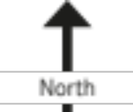 |  |  |  |  |  |  |  |  |  |  |  |  |  |  |  |  |  |  |  |  |  |  | 15
Helipad |  |  |  |  | HP |  |  |  |  |  |  |  |  |  |  |  |  |  |  |  |  |  |  |  |  |  |  |  |  | 16
Other |  |  |  |  |  |  |  |  |  |  |  |  |  |  |  |  |  |  |  |  |  |  |  |  |  |  |  |  |  | 17

INCIDENT ORGANISER VELDFIRE
IIncident Management Structure
Prepared by:
Position:
Date/Time:
Build/Draw your structure
and fill in positions
Names & radio call signs [RCS]
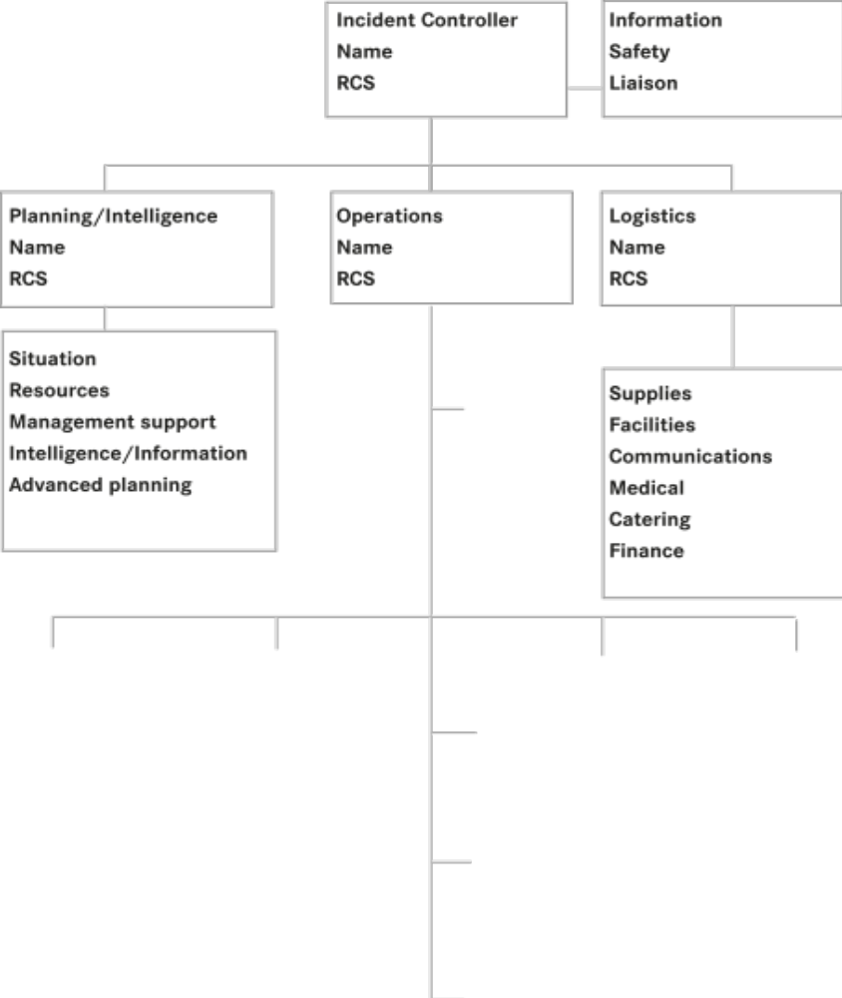

Operational Tasking
Sector | Resource |  | Task |  | Grid | Tasked at hrs

INCIDENT ORGANISER VELDFIRE
Log of Actions Date:
Time: |  | Initials
Completed by:
(All log entries are to be completed in pen. Record time of each entry. Do not leave blank lines between entries. Sign off entries)
Page ____ of____
Comunication Plan:
Command:
Tactical:
Support:
Ground to Air:
Air to Air:

